**UI Overview:**

Must have pages:

1. Login

2. Register (with email)

3. Register cont. (basic health info)

4. Create workout page

a. Create workout page (enter today’s details)

b. Confirm/adjust suggested workout

c. Confirm worked completed

d. Provide Feedback

5. Profile page

a. See profile page

b. Edit profile page

Could have pages:

1. Past workouts

We also need a homepage, unless we treat the login page as the homepage

**Suggestions on overall structure:**

·

**1.** **LOGIN PAGE**

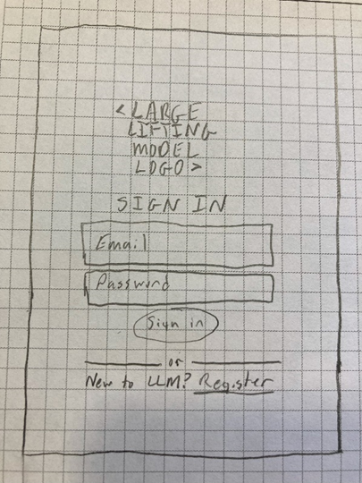

Overview:

- Standard login page - sign in with email/password.

- Click register to go to register page

Considerations:

Optional Functionality:

- Add different ways to sign in (i.e. gmail, facebook, etc.)

Data to store:

- User Email

- User Password

**SUGGESTIONS/DISCUSSION:**

**2.** **REGISTER PAGE (WITH EMAIL)**

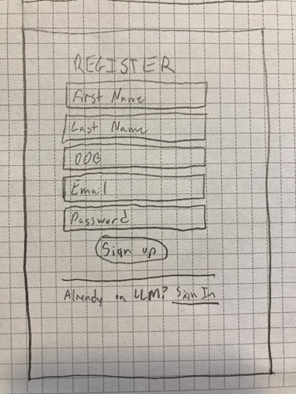

Overview:

- Standard register page – register with name, DOB, email, password

- Click sign in to go back to sign in page

- Once you sign up, take you directly to Register Cont. page

Considerations:

- Need certain password length/type?

Optional Functionality:

- Add different ways to register (i.e. gmail, facebook, etc.)

Data to store:

- User Name/DOB/Email/Password

**SUGGESTIONS/DISCUSSION:**

**3.** **Register cont. (basic health info)**

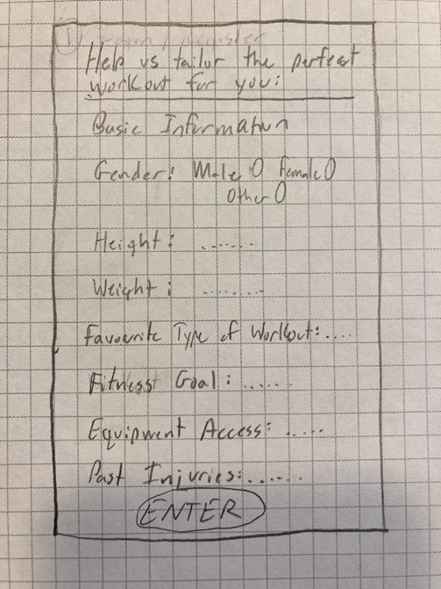

Overview:

- Once you register, add basic health information

- Press enter once you are done to go to main ‘Create a workout’ page

Considerations:

- Need to agree on what fields to add:

o First name/last name

o Age (will come from DOB in register)

o Gender

o Height

o Weight

o Favorite type of workout (cardio, weights, circuits, crossfit, yoga, etc.)

o Fitness goal (lose weight, gain muscle, etc.)

o Equipment access (full gym, no gym, small gym, etc.)

o Past injuries (open ended?)

o What else???

- May be 1 page that you scroll through, or multiple pages with 1 question on each page

Data to store:

- All of the users basic health information to pass to the LLM

**SUGGESTIONS/DISCUSSION:**

**4.** **A) CREATE A WORKOUT PAGE**

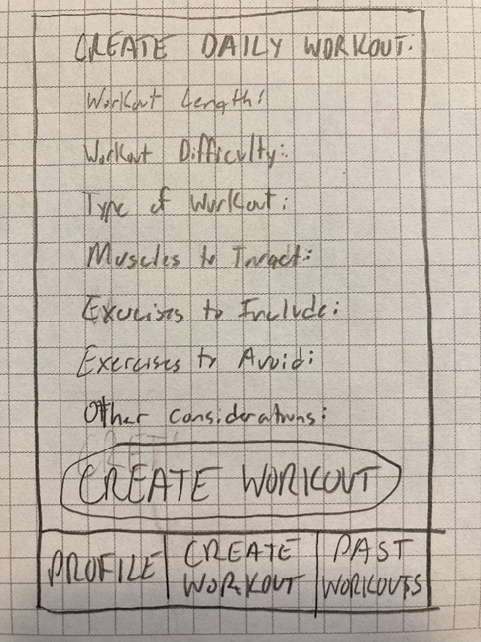

Overview:

- Main page once logged in, fill in fields for today’s workout and press create a workout

Considerations:

- Need to agree on what fields to add:

o Workout length (select minutes)

o Workout difficulty (easy, medium, hard)

o Type of workout (cardio, weights, mix, etc.)

o Muscles to target (chest, back, legs, everything, etc.)

o Exercises to include (open ended?)

o Exercised to avoid (open ended?)

o Other considerations (open ended?)

o HUNGER LEVEL

o What else???

Data to store:

- Don’t think we need to store this info yet?

- This will be passed to LLM + basic workout info + workout history(?) to generate workout.

**SUGGESTIONS/DISCUSSION:**

**4.** **B) Confirm/Adjust Suggested workout**

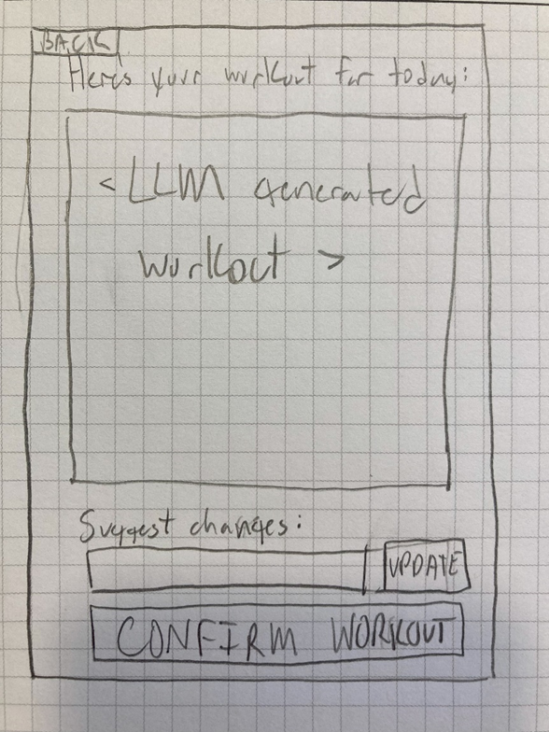

Overview:

- Once you’ve created a workout, have a chance to adjust the workout, or select confirm workout

- Can also go back and update initial information if you want

Considerations:

- Should there just be an open-ended text box on how you’d like to adjust the workout?

Data to store:

- Again, don’t need to store this information yet, but do need to send additional information to LLM if user chooses to adjust the workout

**SUGGESTIONS/DISCUSSION:**

Backend duty, request workouts tab separated so we can parse?

**4. C) CONFIRM WORKOUT COMPLETED**

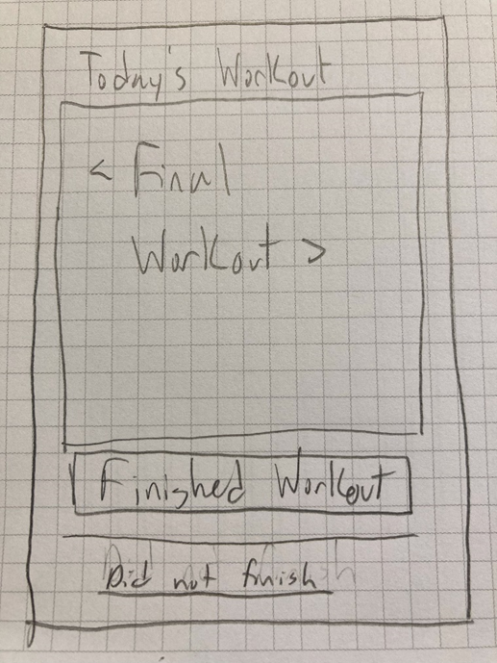

Overview:

- Shows you your final workout you will do.

- Option to select ‘finished workout’ or ‘did not finish’

Considerations:

- How are we going to show the final workout?

Optional features:

- Show workout as tick boxes, so you can select exact exercises that you did or did not complete.

Data to store:

- Once user selects ‘finished workout’ the LLM output of the workout will be stored as a past workout

**SUGGESTIONS/DISCUSSION:**

ELIMINATE THIS - just have 4C with

**4. D) Provide Feedback:**

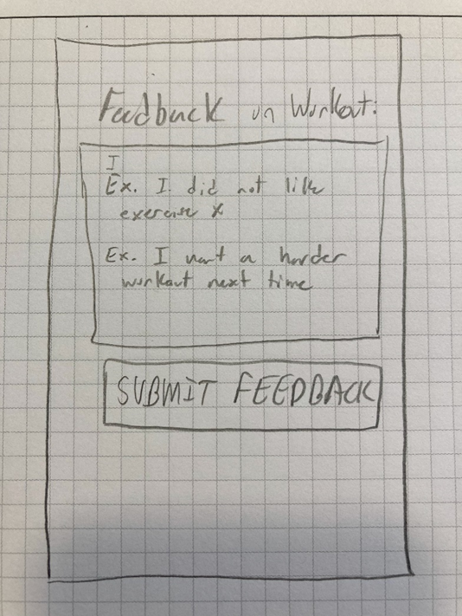

Overview:

- Simple page for the user to provide feedback once the workout is complete

- This data will help future workouts be better aligned with what they want

Data to store:

- This feedback should be stored with the workout they just completed

**SUGGESTIONS/DISCUSSION:**

**5. A) PROFILE PAGE (VIEW)**

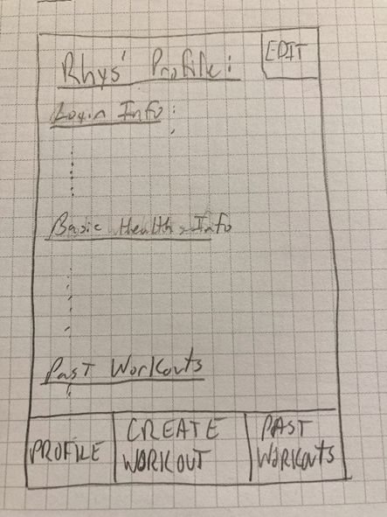

Overview:

- Just shows you the information you’ve entered when you register and have an edit button to allow you to change the information

Data to store:

- This data should already be stored, but if a user edits the page it will need to update the database

**SUGGESTIONS/DISCUSSION:**

**5. B) PROFILE PAGE (EDIT)**

This will be the same as the profile page, but when you select ‘edit’ you can update the information and then click save.

**6) (OPTIONAL) PAST WORKOUTS PAGE**

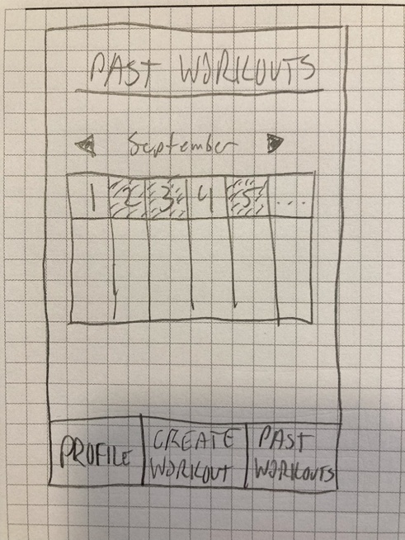

Overview:

- Thought it could be cool to have a calendar view where users can see which days they did a workout, and select the day to see what workout they did.